NAME OF ASSOCIATION, INC.

REQUEST FOR PROPOSAL
LANDSCAPE MANAGEMENT

Purpose This Request For Proposal is for the landscape management and maintenance of the (description and address of property).

Award & Performance Schedule This contract to be awarded (after review of all submitted bids) by the Association Board of Directors, with an anticipated contract start date of January 1, (Year). Initial term of contract is for one year, with renewal opportunities thereafter. Contractors may submit multi-year proposals for consideration only if there is a sufficient price consideration of more than 25% to warrant a multi-year award.

Bidder Requirements Bidders must include copies of their W-9 Taxpayer ID Form, Certificates of Insurance and Florida Contractor License(s) with the bid. Contractor must have and maintain all government mandated licensing throughout duration of contract services.
Minimum Insurance Requirements:
- Commercial General Liability Insurance: Including Bodily Injury and Property Damage Liability, Independent Contractors Liability, Contractual Liability, Product Liability and Completed Operations Liability in an amount not less than $1,000,000 combined single limit, per occurrence, and $2,000,000 aggregate.
- Workers Compensation: Statutory limits are required.
- Automobile Liability: Automobile Liability in an amount not less than $1,000,000 per occurrence for bodily injury and property damage, including owned, hired and non-owned vehicle coverage.
- Other Insurance: any other government mandated insurance requirements.

General Conditions Contractor must schedule any on-site visit with the Community Association Manager, at least two days in advance with a call-in 10-20 minutes prior to arrival. (Contact Name and Info). Contractor is to bid services based on attached Specifications (Appendix A). All bid submissions shall also list contractor’s labor rates for repairs, or other needs not part of the regular maintenance. All bid submissions are due by close of business (Deadline Date). Submissions can be in electronic format emailed to (Named Contact), or printed copy delivered to manager at property address.

Property address is: | Billing address is:

Contractor vehicles must park in the (Desginated Parking) in the area marked in Appendix C.

Note Special Instructions (i.e. routing, security clearance, etc).

APPENDIX A
LANDSCAPE MANAGEMENT SPECIFICATIONS

TURF MAINTENANCE

- Mowing of all turf areas at seven-day intervals during the peak growing season of March to October. Turf areas mowed bi-weekly or as needed during the remainder of the year to ensure a neat, well-maintained appearance. Any excessive clippings as a result of mowing or trimming shall be removed from turf areas; all clippings are to be removed from bed and paved areas during each service visit.
- All turf areas will be trimmed (string trimming) weekly to coincide with mowing.
- Maintain a neat appearance of all turf by power edging (no string trimmer to be used for edging) all sidewalks, curbs, parkways, beds, parking lots and drives weekly during the growing season and as needed during dormant season.
- Bermuda, Zoysia, and Centipede warm season grasses to be mowed to a height of 2-2 ½” whereas St. Augustine turf will be cut at 3-3 ½” during each mowing. Height to be adjusted as conditions warrant (heat, drought, etc.), but shall not exceed removal of more than 1/3 of blade length with any mowing.
- Extra precaution shall be taken during mowing to prevent scalping of uneven high spots or berms. Particular care shall also be exercised to prevent scalp damage due to sharp turning, starting and stopping on turf, etc.
- Trash and debris shall be removed during each visit prior to mowing turf areas.
- All plant beds shall be kept defined and cleared of trash and debris to project a clear definition between turf and shrub location.
- Turf fertilization shall be conducted four times per growing season utilizing rates of fertilizer, specified according to soil analysis. A schedule shall be provided to Association Office of applications.
- Pre-emergence herbicide applications shall be made two times per year for warm season turf to prevent turf weed infestation in turf areas. A schedule shall be provided to Association Office.
- Post emergence herbicides shall be applied to all turf locations during the growing season as needed to control any weed escapes. Applications shall not be made during stressful environmental turf growing conditions.
- Insecticides shall be applied as needed on all turf areas to control non-beneficial insect pests, including, but not limited to, army worms, chinch bugs and mole crickets.
- Disease analysis and the application of effective fungicides to suppress any harmful fungus shall be made as necessary to all turf areas.
- Blowing of all clippings and debris from sidewalks, walkways, curbs, tennis courts, recreational areas and parking lots shall be conducted during each weekly visit.

- Soil testing to be performed once per year and adjustments to pH and other nutrients shall be performed based on results of the testing. A copy of the soil tests results is to be provided to the Property with a plan for appropriate treatments based on testing results. Schedule to be provided to Association Office.

II. SHRUB AND TREE MAINTENANCE

- Pruning of all ornamental shrubs (up to 15’ in height) and ground covers and the removal of any dead branches shall be conducted at least six times per year or as required to insure a neatly shaped appearance. The frequency and configuration of pruning shall depend upon horticultural standards for all shrub species; however, a deep prune to obtain uniformity shall be performed in early winter. Schedule to be provided to Association Office.
- All clippings and pruned branches shall be removed immediately after each pruning completion. All trash and debris removed from beds on as needed basis during each visit.
- Partially dead shrubs shall be trimmed back to remove necrotic areas.
- Pre-emergence herbicides will be applied to all shrub/tree beds prior to weed germination in March/April.
- Post emergence herbicides shall be carefully utilized as spot treatments in shrub beds during the growing season for control of weed escapes. Manual (hand) removal of any weeds over 3” in height shall be performed.
- Fertilization shall be conducted during both spring and fall on all shrub and ornamental trees and be applied at rates conducive for optimum growth (Soil analysis utilized for appropriate types and rates).
- Edging of all shrub/tree beds shall be performed at least bi-weekly, or more often, to maintain a neat, well-manicured appearance.
- Applications of insecticides shall be applied to all shrub/trees (up to 15’ height) areas as needed for control of emerging non-beneficial insects.
- Disease analysis and the application of effective fungicides to control any observed fungus/disease in ornamental trees and shrubs shall be made in a timely manner.
- All small ornamental trees (less than 15’) shall be trimmed to encourage good growth habits. This shall include the removal of all water sprouts, suckers, deformed growth and necrotic branches. All clippings and debris shall be removed from the property during the day of pruning. Pruning up of tree limbs and canopy for pedestrian and vehicular traffic up to 12’ shall be performed as needed.
- Broken or fallen tree branches shall be removed from the property during each weekly visit.
- Fallen leaves shall be removed weekly from the property as needed to maintain a neat, well-manicured appearance. Particular attention shall be paid to control leaf drop of Magnolia trees on property.
- Soil testing to be performed once per year and adjustments to pH and other nutrients shall be performed based on results of the testing. A copy of the soil tests results is to be provided to the Property with a plan for appropriate treatments based on testing results. Schedule to be provided to Association Office.
- All shrubs, groundcovers, and small ornamental trees (up to 15’ height) shall be fertilized twice per year with appropriate fertilizer. Palm trees are to be fertilized twice a year with palm special fertilizer.
- Crepe Myrtles trees are to be pruned every other year, removing cross branching, old seed pods, and approximately 20%-30% of branch canopy. Crepe myrtles are exempt to the small ornamental tree height restrictions of 15’ as noted elsewhere in this specification.
III. Other Services
- (Type of Mulch) to be provided three times a year in February, June, and October. Mulch shall be fresh in nature with good color and not dried or brittle. Mulch shall be clean and be free of weeds, vines, or other debris. All bed lines are to be trenched at time of installation to a minimum depth of 2” and resulting soil dispersed evenly before new mulch applied. These Mulch applications are to be included in contract; mulch height shall be a minimum of 2” in uniform coverage.

- Seasonal Color is included in these specifications at the front entrance and traffic circle twice a year (April and October).

- Irrigation management and adjustment is to be performed weekly to ensure proper coverage and duration for adequate hydration of all turf, groundcover, shrubs, trees, and other plant material. Contractor shall coordinate all schedule changes, special watering, or other needs with the named irrigation management contractor, with notice of changes to Property Manager. Complete irrigation system evaluation is to be performed monthly on all system components to ensure proper coverage and operation. Minor issues, such as head adjustments, cleaning, and replacing filters, is to be included in the monthly evaluation at no charge. If any repairs are needed at additional cost to Property, Contractor will provide written estimate of such repairs for approval prior to any work being performed. All damages to the irrigation system components caused by Contractor, will be repaired at Contractor’s expense. This will include damage from mowing or hitting heads, and cutting of pipes/lines by edging or trenching. Emergency response to main line breaks or major system failure is to be available 24 hours a day, 365 days a year; such emergency repairs will be billed separately.

- Tree pruning or removal of any trees over 15’ in height or 2 1/2” in caliper shall be quoted separately and not included as part of this landscape management contract.

- Severe weather clean up services to be provided on a time and materials basis to Property in the event of natural disaster incidents such as tornadoes, hurricanes, etc. In the event of such occurrences, Contractor is to provide prompt response to assist in restoring property conditions and removing all hazards; such response will be not later than 48 hours after incident, or within 48 hours after “All Clear” has been issued by local authorities if area was under evacuation order. Clean up of Property after “normal” rain or storm events is to be provided at no additional cost at time of regular, weekly service visits.

- Palm tree pruning is to be performed once per year in June and is to be included in landscape management contract. The service shall be performed no later than July 3^{rd.}.

- Landscape Inspection walk-throughs will be conducted once per month with Property Manager and Contractor representative. Date and time will be determined each month based on each party’s available schedule.

IV. Contract Terms

Contractor is to perform all above stated services including all labor, materials, and equipment necessary.

The landscape management contract shall be effective for the period beginning January 1, Year ending December 31, Year.

If there is any deficiency in service or quality, Contractor will be provided notice of such deficiency and will be given 14 days to correct all deficiencies to Property’s satisfaction. Property reserves the right to terminate this contract at any time, with or without cause, by providing 30 days written notice by certified letter.

V. Average Function Frequency Chart
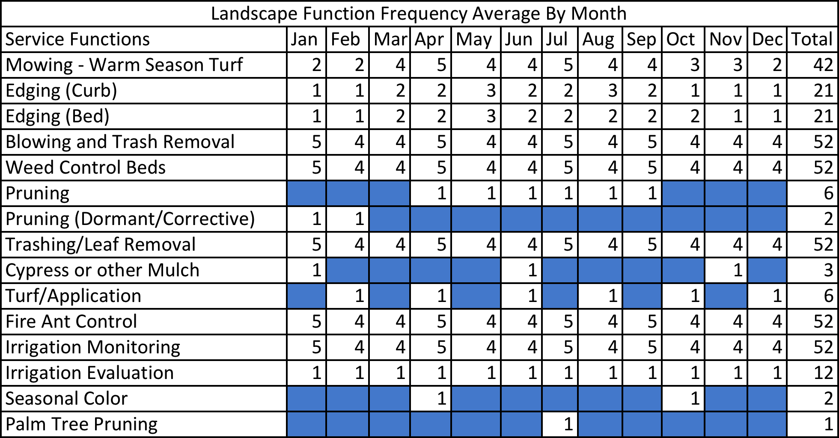
June Pruning

APPENDIX B

Named ASSOCIATION, INC
LANDSCAPE BID SUMMARY

Landscape Maintenance Total
Irrigation Maintenance Total
Mulch Total

Seasonal Color Total

Palm Pruning Total

TOTAL MONTHLY LANDSCAPE SERVICE COST

TOTAL ANNUAL LANDSCAPE SERVICE COST

SUPPLEMENTAL PRICING:

- Mulch (cost for spreading on site)
- Cost per hour – Addt’l Labor w/ truck, handtools, and landscape equipment
- Sod laid, site ready (cost per sq foot)
- Cost per hour - General Labor
- Cost per hour - Irrigation Service (1 Technician)
- Cost per hour – After hours Irrigation Service (1 Technician)
- Seasonal Color installation and maintenance (per square foot)

APPENDIX C

Parking Layout

